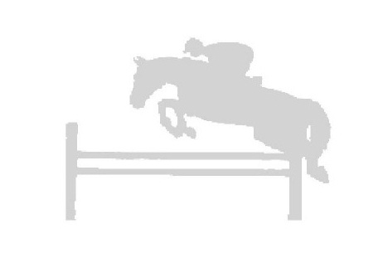
Woodbine Farms
Sari Clapperton Clinic
February 21-22, 2015

Location:
Woodbine Farm
9976 W Liberty Road Chelsea, MI 48118

Rider______________ _____Name of Horse ______ _________

Email___________________________Phone#__________ __________

Address___ ___________________________ ________

Trainer _________________________Phone#__________ __________

Fence height (circle one): 2’-2’3” 2’6”-2’9” 3’ -3’3” 3’6”+

FEES:
$200.00 per horse/rider combination: includes stall.

Participants................................................................................................. $200.00 _______
Audit 1 day.................................................................................................... $20.00 _______
Audit both days............................................................................................. $35.00 _______
Shavings- per bag ......................................................................................... $8.00 _______

.

Make checks payable to SARI CLAPPERTON TOTAL DUE: __________

For More information:
Sari Clapperton
502-314-3411 or sariclapperton@hotmail.com

Mail Registration forms to:
Woodbine Farm
9976 W liberty Rd
Chelsea, MI 48118

